**Project Report on**

**CRM Application That Helps To Book a Visa Slot - Developer - (Short-Term)**

**Introduction:** A visa slot management project is a system that is used to track and manage the availability of visa slots, which are appointments that are required for certain visa applications. It might be used by a government agency or a visa processing center to schedule and manage appointments with applicants.

**Milestone – 01:** Create a Developer Org

Go to developers.salesforce.com/

Click on sign up.

On the sign up form, enter the following details:

1. First name & Last name – NADELLA LAKSHMINARAYANA
2. Email – nadiendilalakshminarayana@gmail.com
3. Role : Developer
4. Company : GAYATRI DEGREE COLLEGE - TIRUPATI
5. County : India
6. Postal Code : 517501
7. Username :

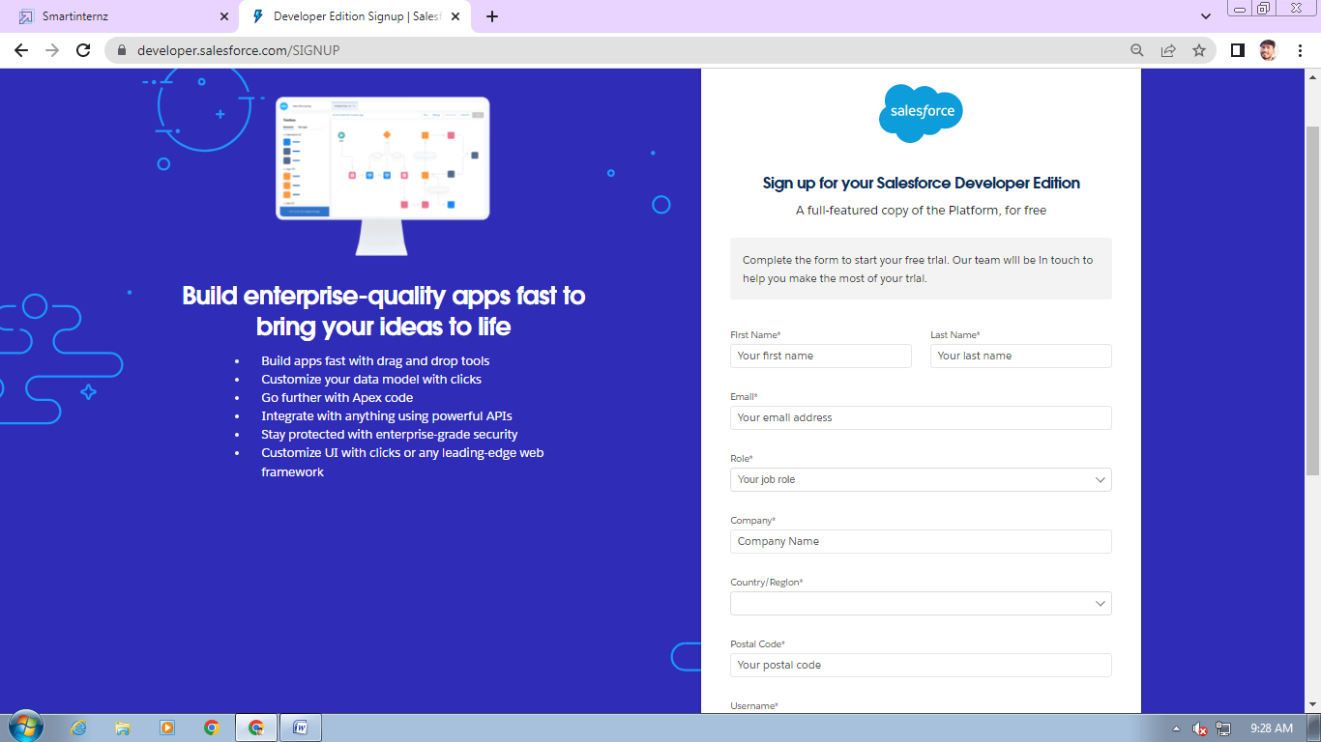

**Account Activation**

Go to the inbox of the email that you used while signing up. Click on the verify account to activate your account. The email may take 5-10mins, as

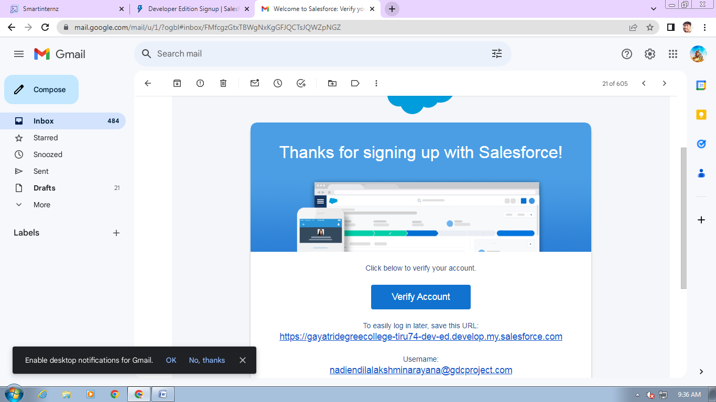

**Login to Your Salesforce Account**

1. Go to salesforce.com and click on login.
2. Enter the username and password that you just created.
3. After login this is the home page which you will see.

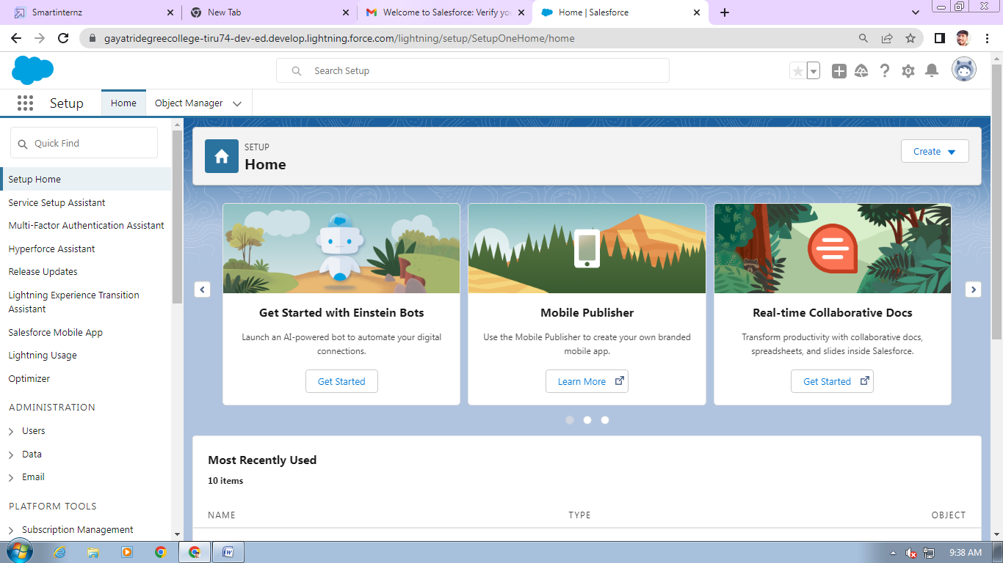

**Milestone – 02: Creation of Objects**

**Object – Passport:**

1. Click on the gear icon and then select Setup
2. Click on the object manager tab just beside the home tab
3. After the above steps, have a look on the extreme right you will find a Create Dropdown click on that and select Custom Object
4. On the Custom Object Definition page, create the object as follows:
5. Label: **Passport**
6. Plural Label: Passports
7. Record Name: Passport Number
8. Check the Allow Reports checkbox
9. Check the Allow Search checkbox
10. Click Save

**Object-Visa Slot:**

1. Click on the gear icon and then select Setup.
2. Click on the object manager tab just beside the home tab.
3. After the above steps, have a look on the extreme right you will find a Create Drop down click on that and select Custom Object
4. On the Custom Object Definition page, create the object as follows:
5. Label: **Visa Slot**
6. Plural Label: Visa Slots
7. Record Name: Visa Slot Number(Auto Number)

**Object-Payment:**

1. Click on the gear icon and then select Setup. Click on the object manager tab just beside the home tab.
2. After the above steps, have a look on the extreme right you will find a Create Drop down click on that and select Custom Object.
3. On the Custom Object Definition page, create the object as follows:
4. Label: **Payment**
5. Plural Label: Payments
6. Record Name: Transaction Id (Auto Number)
7. Check the Allow Reports check box
8. Check the Allow Search check box
9. Click Save.

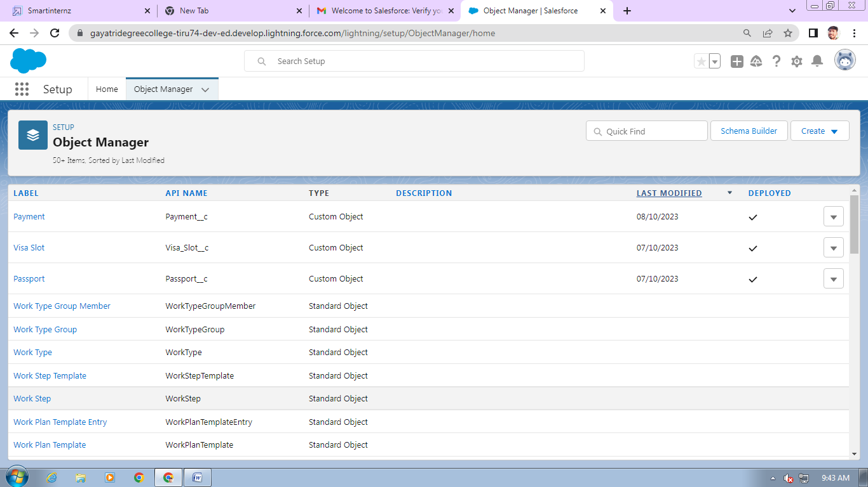

**Milestone – 03: Relationship Creation**

1. Fields Creation: **Passport Number**
2. Navigate to setup
3. Click on Object Manager and search and select Visa Slot object
4. Select Fields & Relations and click New.
5. Select Data Type: Master-Detail, next.
6. Related to: Passport, next.
7. Label: Passport Number
8. Child Relationship Name: Visa Slot, next.
9. Next, next and save.

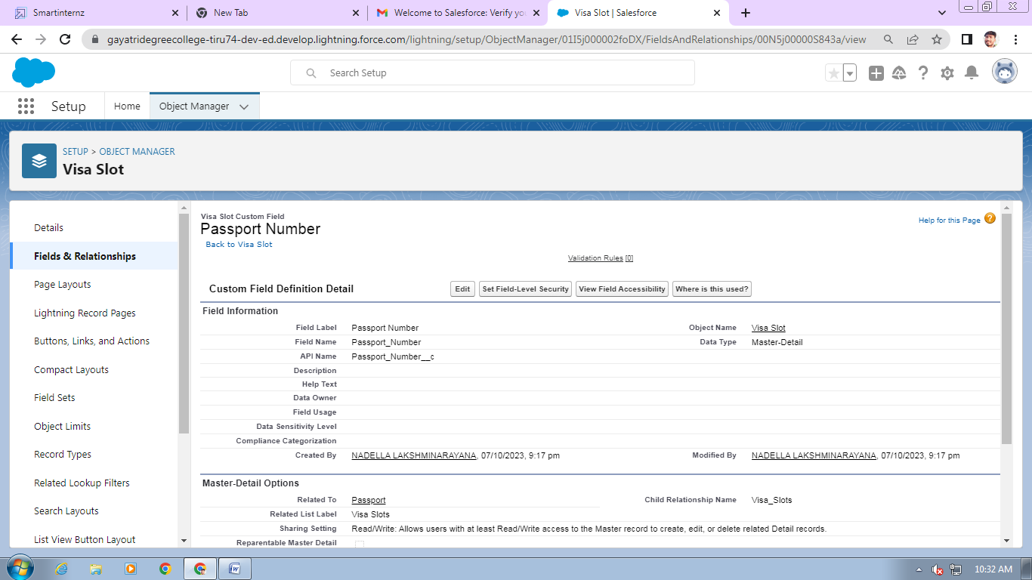

**Milestone – 04:** **Field Creation**

**Field - Full Name:**

1. Navigate to Setup
2. Click the Object Manager next to Home Tab
3. Type **Passport** in Quick Find and Select it
4. Click on Fields and Relationships
5. Click New
6. Select Data Type: Text, click on next
7. Field Label: **Full Name**
8. Length: Max 80
9. Check always requires a value to save this record
10. Click next
11. Next, Save or Save & New (if further new field will be create)

**Field-** **Contact Number:**

1. Navigate to Setup
2. Click the Object Manager next to Home Tab
3. Type **Passport** in Quick Find and Select it
4. Click on Fields and Relationships
5. Click New
6. Select Data Type: Number, click on next
7. Field Label: Contact Number
8. Length: 10 and Decimal 0, click on next
9. Next, Save.

**Field-** **Permanent Address:**

1. Navigate to Setup
2. Click the Object Manager next to Home Tab
3. Type **Passport** in Quick Find and Select it
4. Click on Fields and Relationships
5. Click New
6. Select Data Type: Text Area, click on next
7. Field Label: Permanent Address
8. Next, next and save

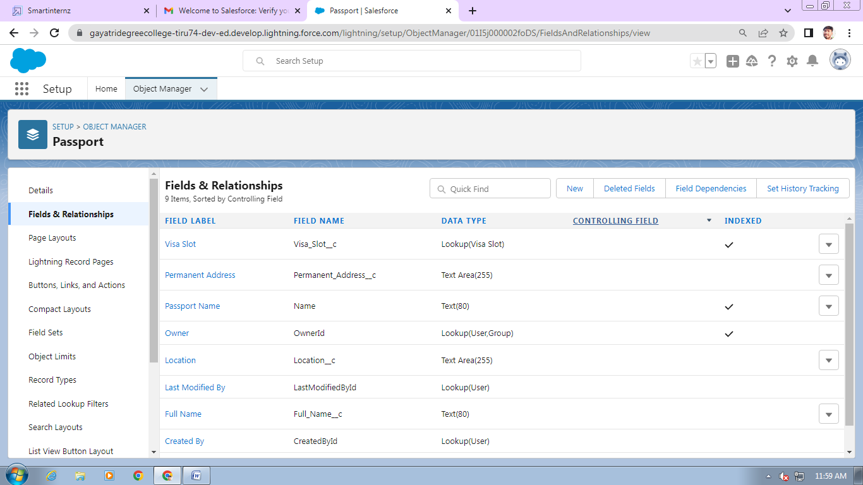

**Fields Available On Custom Object: Visa Slot**

**Field Label Object**

Slot Field Name Data Type

Location               Text

Time                 Date & Time  
Visa Slot Number Auto Number (Use in Record Name)   
Passport Number Master-Detail  
Status                 Picklist

**Fields-Status**

1. Click on Object Manager, search and select**Visa Slot**
2. Click Fields & Relatioships and click on new.
3. Chose on picklist, next.
4. Label: **Status**
5. NOTE- select enter value, with each value separated by new line
6. Values: Approved
7. Cancel Reschedule
8. Next, next and save.

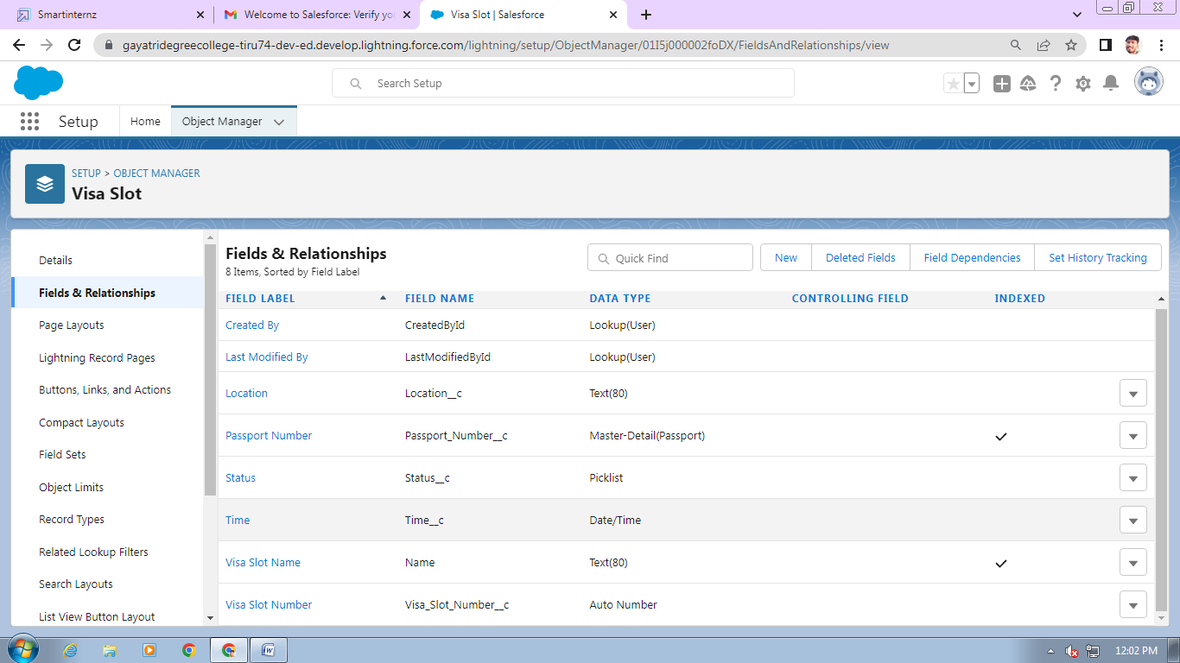

**Field Available On Custom Object: Payment**

Field Name       Data Type

Payment Mode Picklist (Values- Debit Card, Credit Card)   
Card Number       Number  
Transaction Id Auto Number (Used in Record Name)  
Visa Slot Number Master-Detail  
Cancel Transaction Text

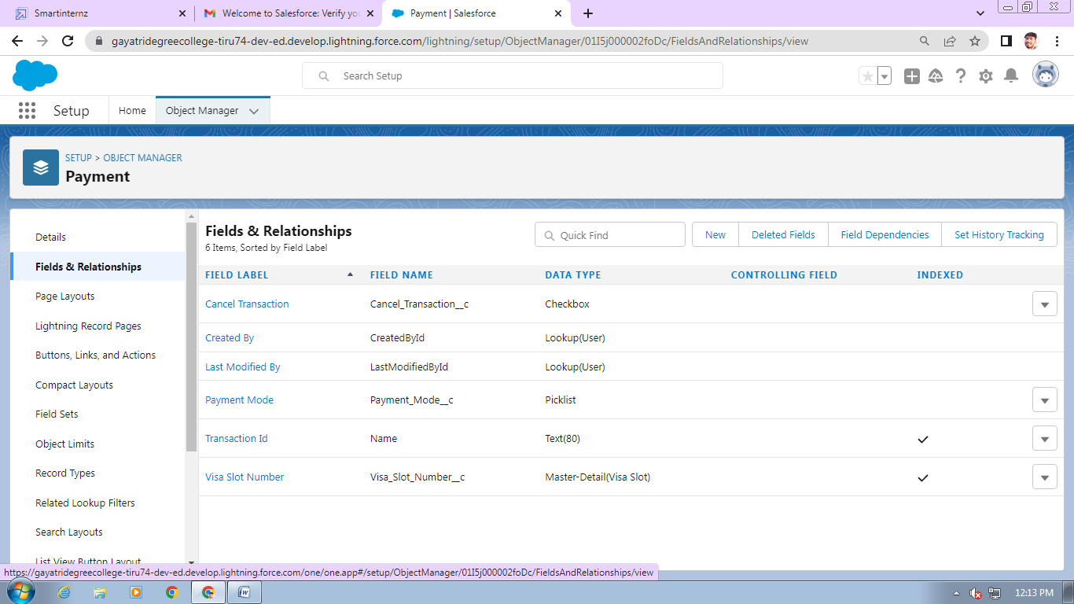

**Milestone – 04:** **Creation Of App**

1. Click on setup and go to home page.
2. In Quick Find Box search and select App Manager.
3. Click: New Lightning App.
4. App Name: Book My Visa and click on next.
5. Navigate System: Standard Navigation Support Form Factor: Desktop and Phone Click next, next
6. Move Objects from available items to selected items. (Passport, Visa Slot, Payment).
7. Add System Administrator profile, available profile to selected profile.
8. Save & Finish

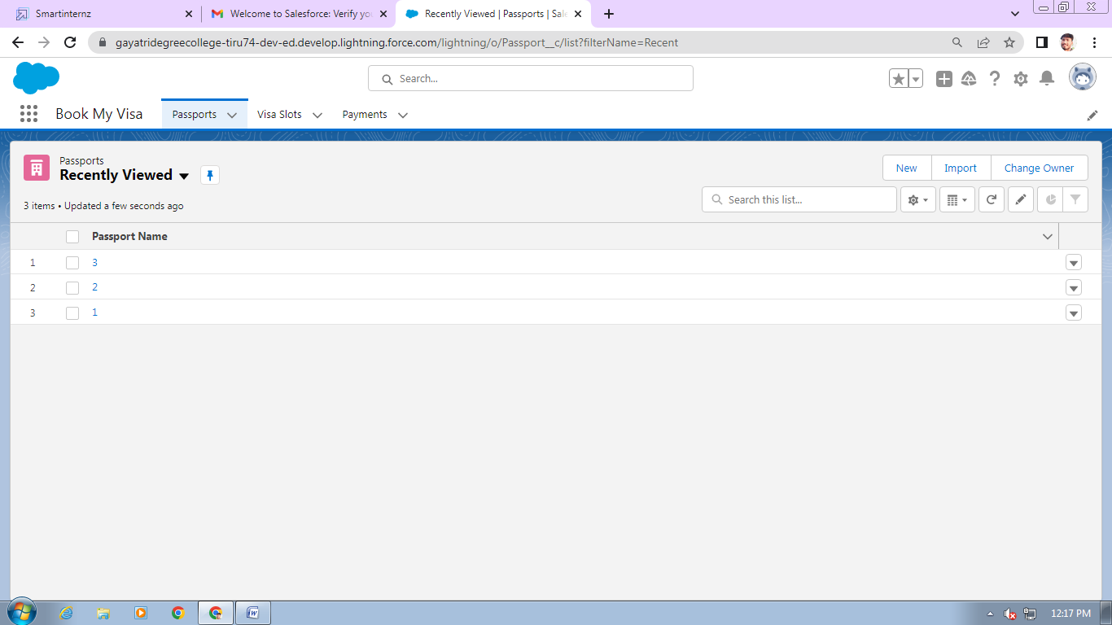

**Milestone – 04:** **Creation Of User**

1. Navigate to setup
2. In Quick Find box select and search: User
3. Click: New user
4. Give First and Last Name
5. Enter your email in the email field
6. Enter user name, it must be unique
7. User license: salesforce platform
8. In the profile field: Standard user profile
9. Check, Generate new password and notify user immediately

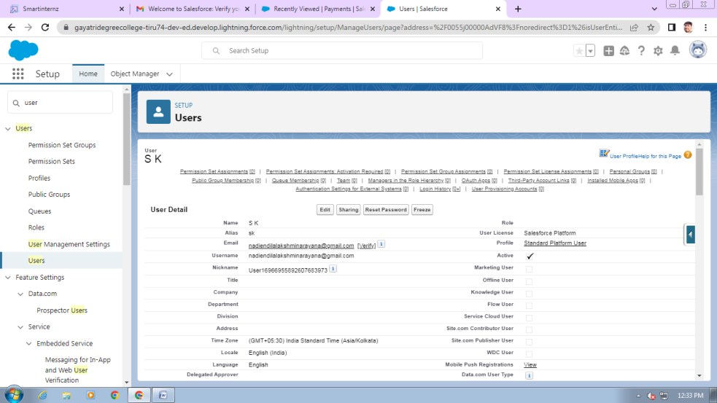

### App Organization Wide Defaults Settings

1. Steps of OWD settings:
2. Navigate setup in Quick Find search bar
3. Type Sharing Setting and Select it.
4. Edit: Organization Wide Defaults.
5. Scroll down list and select Passport object and change the default external Access to Public Read/Write.
6. Save.

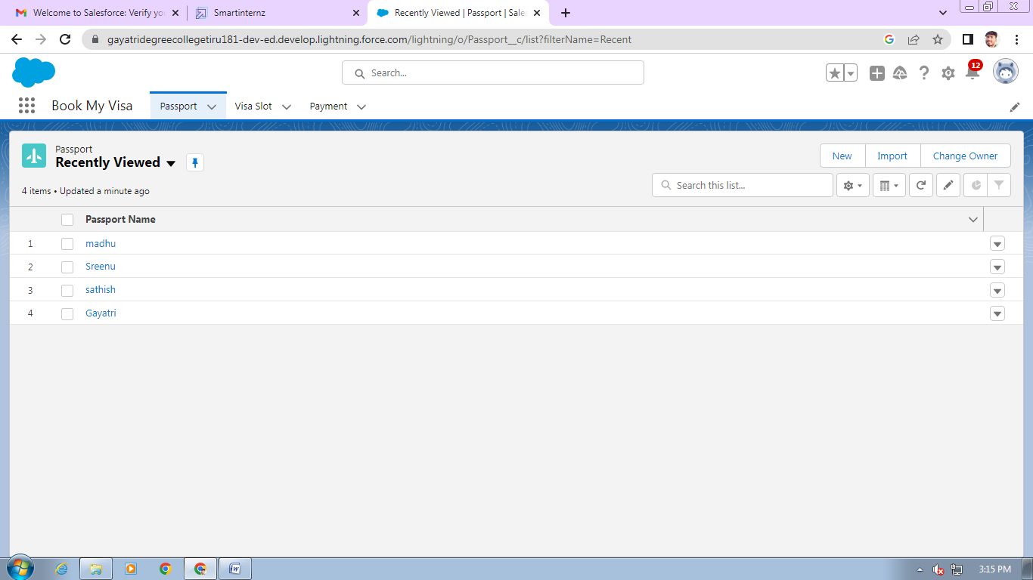

**Milestone – 05:** **User Adoption**

**Create Record- Passport:**

1. Click on App Launcher on left side of screen.
2. Search Book My Visa App & click on it.
3. Click on Passport tab.
4. Click new button
5. Fill all Passport record details.
6. 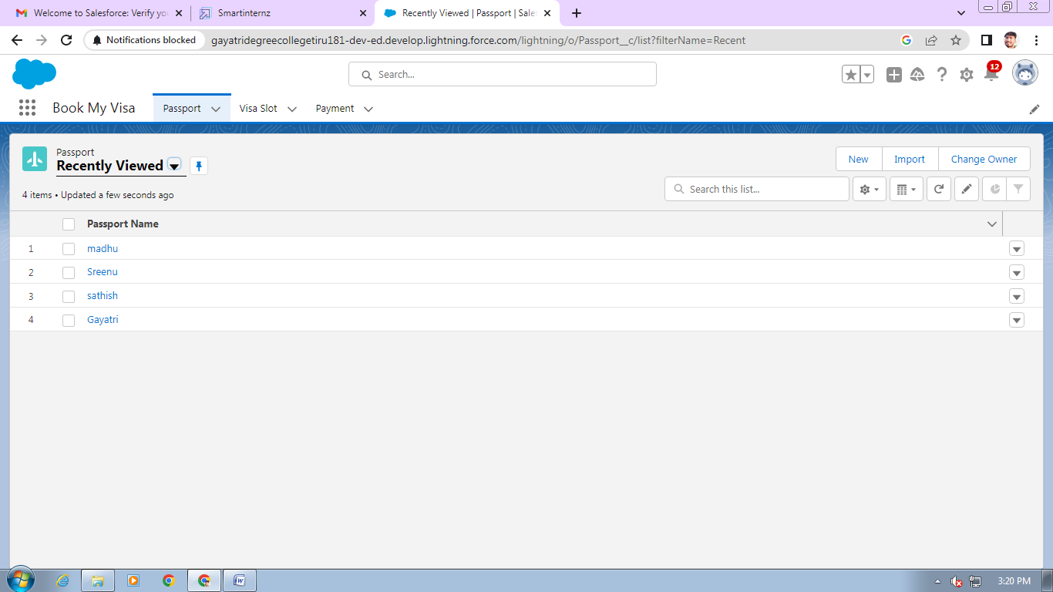Click on Save Button.

**View Record- Passport:**

1. Click on App Launcher on left side of screen.
2. Search Book My Visa & click on it.
3. Click on Passport Tab.
4. Click on any record name. you can see the details of the Driver 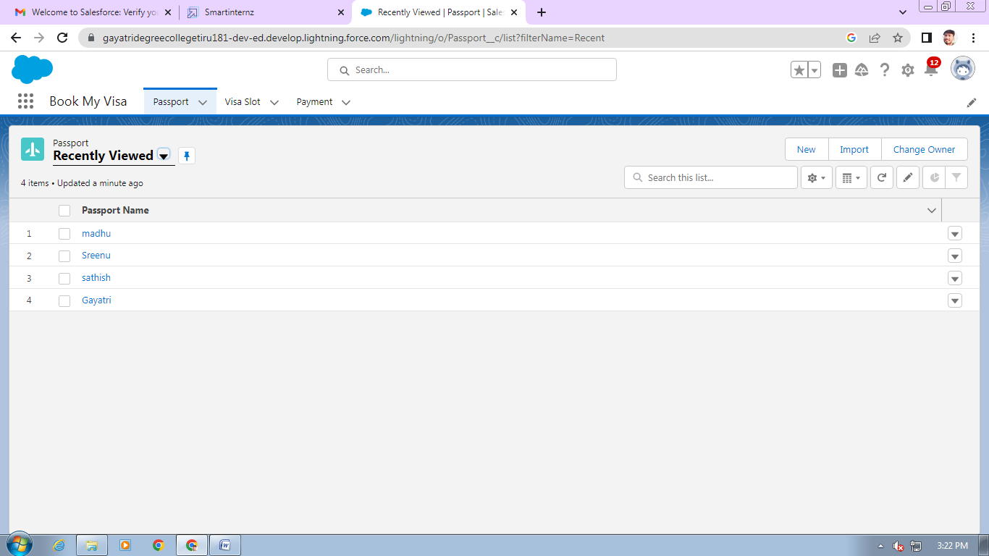

**View** **Delete Records- Passport:**

1. Click on App Launcher on left side of screen.
2. Search Book My Visa & click on it.
3. Click on Passport Tab.
4. Click on Arrow at right hand side on that Particular record.
5. Click delete and delete again. 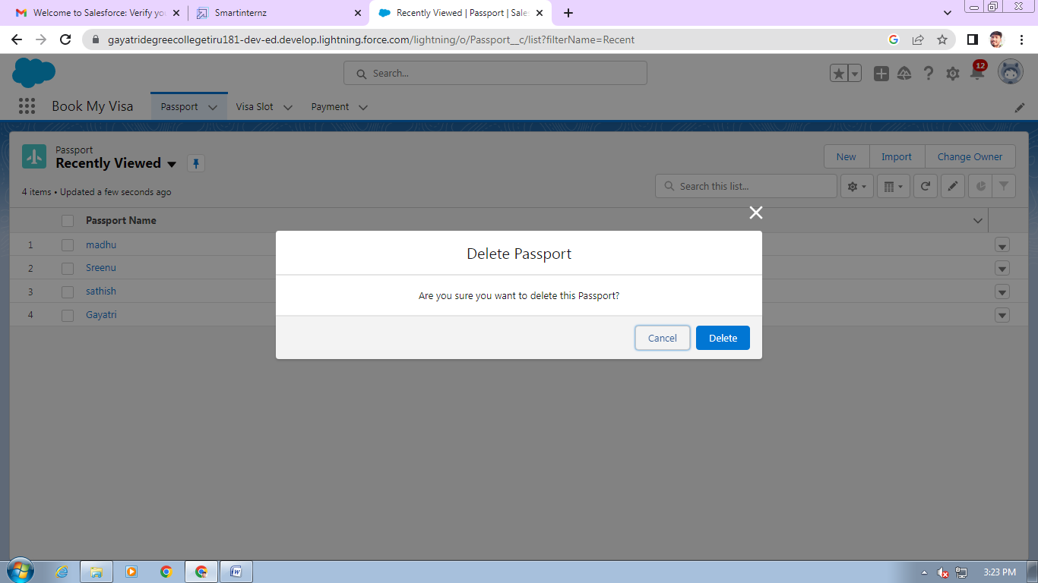

**Milestone – 06:** **What Are Reports?**

**Creation Of Report**

1. Click on App Launcher left side on the screen, Search and select: Report
2. Click Report- select New Report
3. Select Report Type: Passport with Visa Slot Number
4. Click on Start Report button
5. Below the Outline pane- In the Group Row select: Location
6. In Group Column select- Passport: Passport Number
7. In Column select: Visa Slot Number
8. Now navigate to Filter pane available next to Outline pane And ensure in the show me section: All Passport is selected
9. In Passport Created date: All Time.
10. Give the Label: Passport with Visa Location
11. Save & Run for saving the Report, Save. 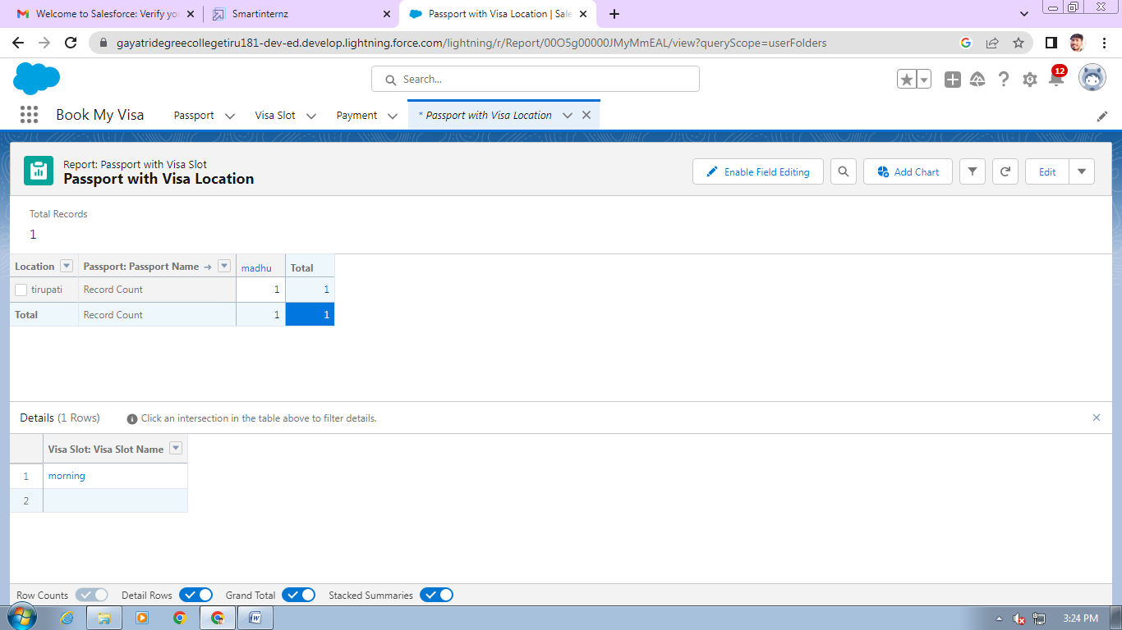

**View Report:**

1. Click on App Launcher on left side of screen.
2. Search Book My Visa App & click on it.
3. Click on Reports Tab.
4. Click on Passport with Visa Location and see reports. 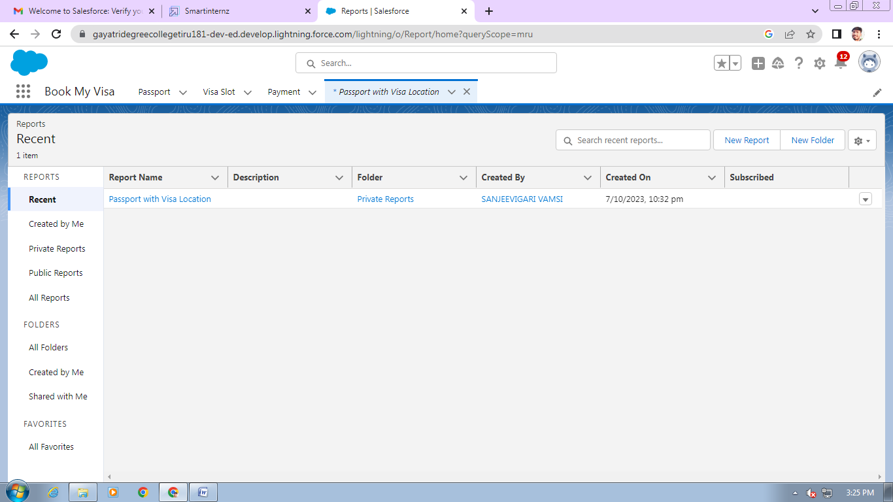

**Milestone – 06:** **Dashboards**

**Creation Of Dashboard**

1. Click on the App launcher left on screen and search for dashboards.
2. Select New Dashboard
3. Name the Dashboard: Passport With Visa Location
4. Select Create option
5. Click on Add Component
6. Select Passport with Visa Locations
7. Click Select
8. Select the Donut Chart to display a section
9. Value: Record count
10. Sliced By: Location
11. Leave the default values
12. Click on Add
13. Save the Dashboard and Done 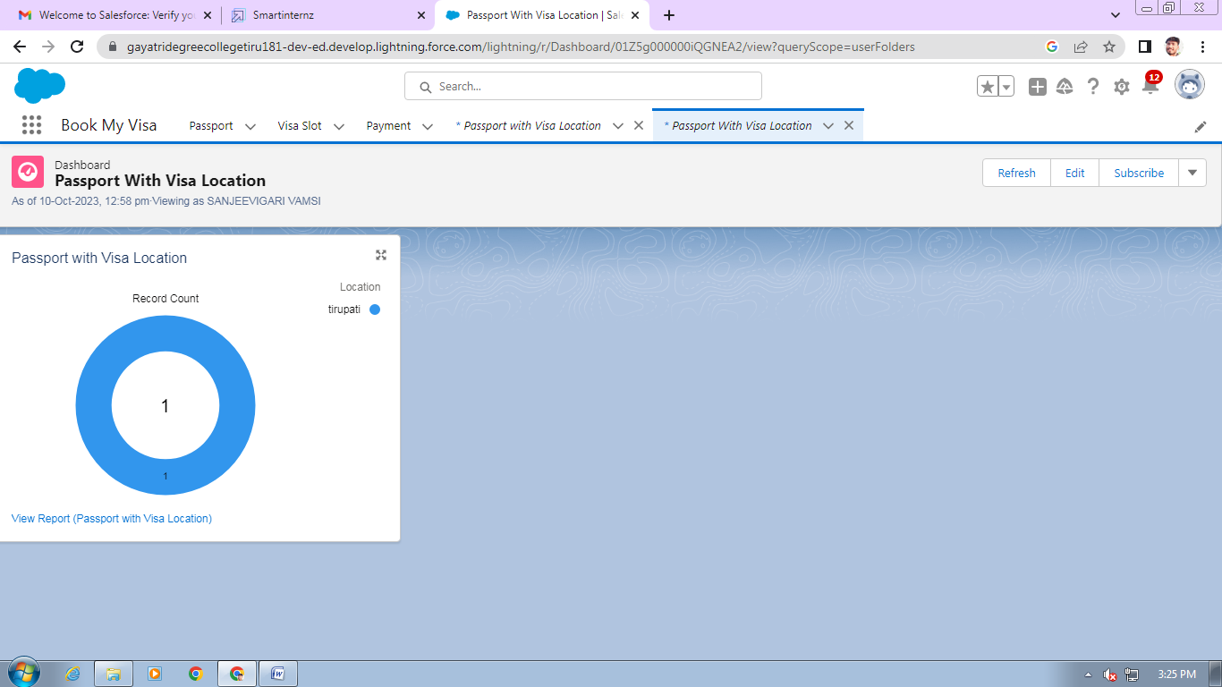

**View Dashboard:**

1. Click on App Launcher on left side of screen.
2. Search Book My Visa & click on it.
3. Click on Dashboard Tab.
4. Click on Passport with Visa Location see graph view of records

**Milestone – 07:** **Apex Triggers**

1. **Write A Trigger-1:** Click on Set up Gear at drop down list you can find developer console click on that.
2. At the left side top you can find the option new click on that and then apex trigger.
3. Give the name as **Deletionofvisarecord**
4. And S object has**Visa Object**
5. Scenario - **You cannot delete active visa record**

|  |
| --- |
| trigger Deletionifvisarecord on Visa_Slot__c (before delete) {      List<Visa_Slot__c> ApprovedVisa = [SELECT Id, Status__c FROM Visa_Slot__c WHERE Id IN :Trigger.old AND Status__c = 'Approved'];       for (Visa_Slot__c Visa : ApprovedVisa) {          Visa.addError('Cannot delete an active Visa.');      }  } |

**Write A Trigger-2:**

1. Click on Set up Gear at drop down list you can find developer console click on that.
2. At the left side top you can find the option new click on that and then apex trigger.
3. Give the name as AvoidDuplicatePassport
4. And S object has Passport Object
5. Scenario - trigger on the Passport__c object to avoid duplicate records based on the Full Name and Contact Number fields.

|  |
| --- |
| trigger AvoidDuplicatePassports on Passport__c (before insert, before update) {       Set<String> uniqueKeys = new Set<String>();       List<Passport__c> duplicatePassports = new List<Passport__c>();       for (Passport__c passport : Trigger.new) {           String key = passport.Full_Name__c + '_' + passport.Contact_Number__c;          if (uniqueKeys.contains(key)) {              duplicatePassports.add(passport);          } else {              uniqueKeys.add(key);          }      }      for (Passport__c passport : duplicatePassports) {          passport.addError('Duplicate record found based on Full Name and Contact Number.');      }  } |

### The End